**Code:**

<!DOCTYPE html>

<html>

<head>

<title>Quiz Master Dashboard</title>

<meta name="viewport" content="width=device-width, initial-scale=1">

<link rel="stylesheet" href="https://maxcdn.bootstrapcdn.com/bootstrap/4.5.2/css/bootstrap.min.css">

<script src="https://ajax.googleapis.com/ajax/libs/jquery/3.5.1/jquery.min.js"></script>

<script src="https://cdnjs.cloudflare.com/ajax/libs/popper.js/1.16.0/umd/popper.min.js"></script>

<script src="https://maxcdn.bootstrapcdn.com/bootstrap/4.5.2/js/bootstrap.min.js"></script>

<style>

body {

font-family: Arial, Helvetica, sans-serif;

background-color: #dfdfdf;

}

.sidebar {

background-color: #002549;

color: #fff;

height: 100%;

position: fixed;

left: 0;

width: 240px;

z-index: 1;

overflow-x: hidden;

}

.sidebar a {

padding: 6px 8px 6px 16px;

text-decoration: none;

font-size: 20px;

color: #c4c4c4;

display: block;

}

.sidebar a:hover {

color: white;

background-color: #4CAF50;

}

.main {

margin-left: 240px;

padding: 0px 10px;

overflow-x: hidden;

}

.header {

background-color: #102325;

color: #fff;

height: 70px;

display: flex;

align-items: center;

justify-content: space-between;

padding: 0px 20px;

box-shadow: 0px 2px 10px rgba(0, 0, 0, 0.1);

}

.header h2 {

font-size: 24px;

font-weight: bold;

margin: 0px;

}

.stats-card {

background-color: #d3f1ff;

box-shadow: 0px 2px 10px rgba(0, 0, 0, 0.1);

padding: 20px;

margin-top: 20px;

margin-bottom: 20px;

}

.stats-card h3 {

font-size: 20px;

font-weight: bold;

margin-top: 0px;

margin-bottom: 10px;

}

.stats-card p {

font-size: 24px;

font-weight: bold;

margin-top: 0px;

margin-bottom: 0px;

color: #343a40;

}

.stats-card.pass-rate p {

color: #28a745;

}

.commonDiv {

display: flex;

width: 100%;

height: 50%;

flex-direction: row;

}

.table {

text-align: center;

width: 90%;

height: 90%;

border-collapse: collapse;

margin: 25px 25px 25px 25px;

font-size: 0.9em;

font-family: sans-serif;

min-width: 400px;

box-shadow: 0 0 20px rgba(0, 0, 0, 0.15);

}

table, th, td{

border: 2px #000;

}

.table thead tr {

background-color: #009879;

color: #ffffff;

text-align: left;

}

.activity-card {

background-color: #fff;

box-shadow: 0px 2px 10px rgba(0, 0, 0, 0.1);

padding: 20px;

padding-bottom: 10px;

margin-top: 25px;

}

.activity-card h3 {

font-size: 20px;

font-weight: bold;

margin-top: 0px;

margin-bottom: 10px;

}

.activity-card ul {

list-style-type: none;

padding-left: 0px;

display: flex;

flex-direction: column;

}

.activity-card ul li {

margin-bottom: 2%;

}

.activity-card ul li .badge {

font-size: 14px;

padding: 6px 10px;

margin-right: 10px;

border-radius: 5px;

font-weight: bold;

text-transform: uppercase;

}

.activity-card ul li .badge-primary {

background-color: #007bff;

color: #fff;

}

.activity-card ul li .badge-success {

background-color: #28a745;

color: #fff;

}

.activity-card ul li .badge-warning {

background-color: #ffc107;

color: #000;

}

.activity-card ul li .badge-danger {

background-color: #dc3545;

color: #fff;

}

.footer {

background-color: #282b2e;

color: #fff;

height: 50px;

display: flex;

align-items: center;

justify-content: center;

position: fixed;

bottom: 0;

left: 0;

width: 100%;

z-index: 1;

}

.footer p {

margin: 0px;

font-size: 14px;

font-weight: bold;

text-align: center;

}

</style>

</head>

<body>

<header class="header">

<div class="container-fluid">

<div class="d-flex flex-row">

<div class="col-lg-9">

<h1>Quiz Master</h1>

</div>

<form class="form-inline my-2 my-lg-0 d-flex flex-row">

<input class="form-control mr-sm-2" type="search" placeholder="Search" aria-label="Search">

<button class="btn btn-primary my-2 my-sm-0" type="submit">Search</button>

</form>

</div>

</div>

</header>

<div class="sidebar d-flex flex-column align-items-center" style="gap: 2%;">

<a class="w-100 d-flex flex-column align-items-center" href="#">Dashboard</a>

<a class="w-100 d-flex flex-column align-items-center" href="#">All Quiz</a>

<a class="w-100 d-flex flex-column align-items-center" href="#">Profile</a>

<a class="w-100 d-flex flex-column align-items-center" href="#">Subscription</a>

<a class="w-100 d-flex flex-column align-items-center" href="#">Logout</a>

</div>

<div class="main">

<div class="row">

<div class="col-md-4">

<div class="stats-card rounded">

<h3>Total Quiz Attrempted</h3>

<p>12</p>

</div>

</div>

<div class="col-md-4">

<div class="stats-card rounded">

<h3>Completely Solved Quiz</h3>

<p style="color: #28a745">5</p>

</div>

</div>

<div class="col-md-4">

<div class="stats-card rounded">

<h3>Partially Solved Quiz</h3>

<p>8</p>

</div>

</div>

<div class="col-md-4">

<div class="stats-card rounded">

<h3>Active Quiz</h3>

<p style="color: #007bff">45</p>

</div>

</div>

<div class="col-md-4">

<div class="stats-card rounded">

<h3>Total Quiz Available</h3>

<p>57</p>

</div>

</div>

<div class="col-md-4">

<div class="stats-card rounded">

<h3>Accuracy</h3>

<p>75%</p>

</div>

</div>

</div>

<div class="commonDiv">

<div>

<table class="table">

<thead>

<tr>

<th scope="col">Sr No.</th>

<th scope="col">Quiz Code</th>

<th scope="col">Quiz Score</th>

<th scope="col">Correct Question</th>

<th scope="col">In-Correct Question</th>

<th scope="col">Total Question</th>

</tr>

</thead>

<tbody>

<tr>

<th scope="row">1</th>

<td>QM15</td>

<td>15</td>

<td>15</td>

<td>5</td>

<td>20</td>

</tr>

<tr>

<th scope="row">2</th>

<td>QM27</td>

<td>55</td>

<td>55</td>

<td>15</td>

<td>70</td>

</tr>

<tr>

<th scope="row">3</th>

<td>Qm125</td>

<td>10</td>

<td>10</td>

<td>5</td>

<td>15</td>

</tr>

</tbody>

</table>

</div>

<div class="activity-card">

<h3>Recent Activities</h3>

<ul>

<li><span class="badge badge-primary">Quiz Attempt</span>Rajat Nawale Attempt Quiz No: <a

href="#">12</a></li>

<li><span class="badge badge-success">Quiz Add</span>Durgesh Mahajan added new Quiz Quiz No:<a

href="#">75</a></li>

</ul>

</div>

</div>

</div>

<div class="footer">

<p> &copy; Quiz Master 2023</p>

</div>

</body>

</html>

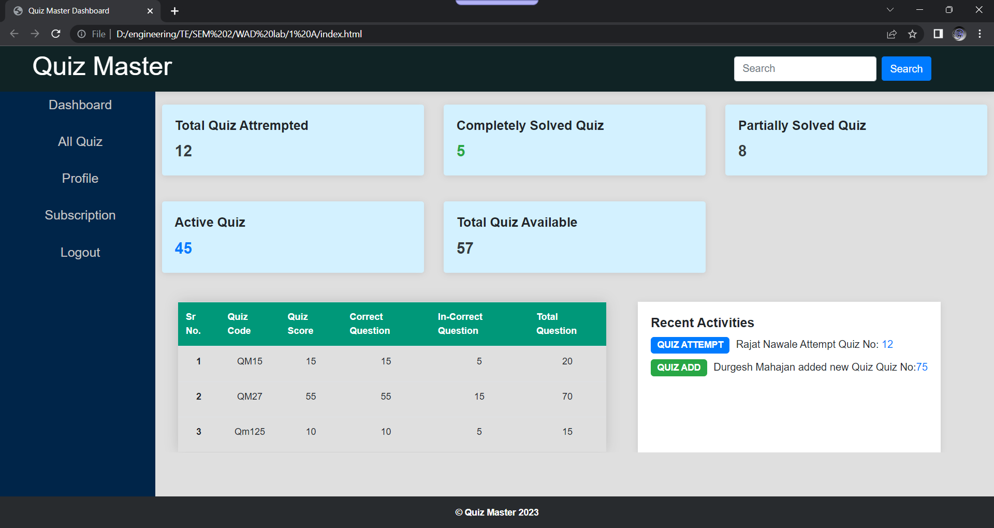**Output:**